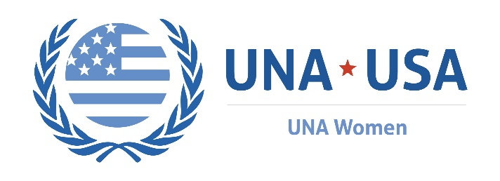
International Women’s Day  UN Women Theme:  “I AM GENERATION EQUALITY: REALIZING WOMEN’S RIGHTS”  sunday, March 8th, 2020 |  | Host a panel WITH local businesses  International Women’s Day is a perfect time to engage businesses in your community to learn about ways that they are conducting business through a gender equity lens.  A great way to engage local businesses is to host a diverse panel of business owners to discuss this year’s UN Women theme, gender equity in the workplace, and best practices for other business owners and corporations in attendance.  Your event could be open to the public, and you could invite local community members, UNA chapter members, business owners, leaders of non-profits, representatives of Chambers of Commerce, Members of Congress, and state and local lawmakers.  In addition to business panelists discussing best practices for doing business that champions gender equality, community members would learn more about the business practices of the local businesses they frequent.  For instance, the discussion could center around:  - The number of women employees in their company  - The number of women in leadership roles in their company  - If the business owner(s) are women, opportunities for women-owned businesses for funding/investors.  - Pay equity  - Company policies around diversity and inclusion  - How products and/or services are equitably produced  - Whether the business supports local community-based programs that empower women and girls  This event could also serve as a space for networking between businesses and their local community members.

