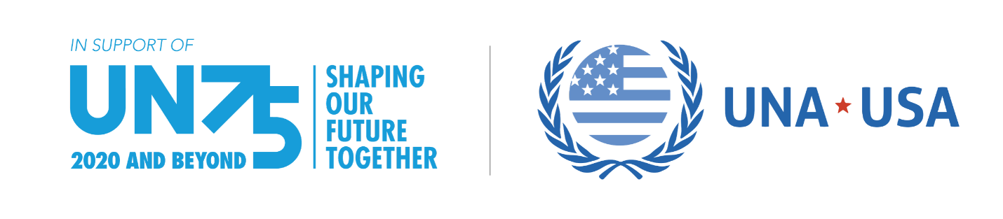

United Nations Association-Chapter Name Commemorates the United Nation’s 75th Anniversary with a Global Consultation in [City, State]

Who: United Nations Association-Chapter Name

What: (Event Title)

When: (Event Date)

Where: (Event Location)

Contact: (President or Press Contact Information)

CITY, STATE, DATE - The United Nations Association-CHAPTER NAME, (CHAPTER ABBREVIATION), is pleased to announce its EVENT TITLE event to celebrate and commemorate the United Nations 75th Anniversary. On DATE/TIME at LOCATION, CHAPTER ABBREVIATION will host a Global Consultation to provide an opportunity for its members and others in the community to share their visions for the future which will ultimately help the UN set its priorities for the next 25 years. The United Nations Association of the USA (UNA-USA) is engaging its network of more than 20,000 members and over 200 chapters across the country to host Global Consultations with the goal of involving Americans in all 50 states and Washington, D.C.

In January, UN Secretary-General António Guterres announced that the UN is hosting the largest-ever global conversation on the role of global cooperation in building the future we want. This worldwide campaign commemorates the UN’s 75th anniversary by engaging individuals, civil society, businesses, and political leaders in sharing their hopes for the future. Topics for discussion include human rights, poverty and inequality, cybersecurity, and climate change.
Notes and recommendations from the Global Consultations will be provided to the UN and key decision makers within the public sector, including Members of Congress.

To learn more about the United Nations and its 75th anniversary, visit: https://www.un.org/en/un75

To learn more about the UNA-USA’s UN75 Global Consultations, please visit: https://unausa.org/un75-toolkit/

###

About the United Nations Association of the USA (UNA-USA):

The United Nations Association of the USA (UNA-USA) is a grassroots movement of Americans who support the vital work of the United Nations in U.S. communities, colleges, and Congress. For more than 75 years, UNA-USA and its national network of 20,000 members and 200 chapters have promoted strong U.S. leadership at the UN through advocacy campaigns, youth engagement, outreach programs, and public events. Learn more.

The ………………………………………………………. Chapter (Division) is …………………………………………………………………………………………………..
………………………………………………………………………………………………….
………………………………………………………………………………………………….

