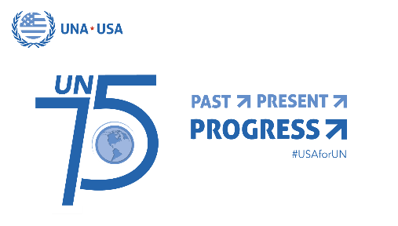

United Nations 75th Anniversary Proclamation
2020 and Beyond: Shaping Our Future Together
Whereas, 2020 marks the 75th anniversary of the founding of the United Nations since the Charter was signed in San Francisco on June 26, 1945, and came into force on October 24, 1945;
Whereas, for 75 years, the United Nations, born from the rubble and devastation of World War II, has provided a forum for international cooperation and diplomacy, and been a beacon of light for multilateralism, international peace and security, economic and social well-being, and human rights for all;
Whereas, the active participation of global civil society, governments and world leaders is an essential component for the continued success and strength of the United Nations and the collective fulfillment of the United Nations Sustainable Development Goals by 2030, as approved unanimously by Member States;
Whereas, the United Nations has remained an indispensable partner for the United States to protect our national security, economic, environmental, and foreign policy interests, as well as to promote our nation's historic shared values;
Whereas, the United Nations has declared the theme of this year’s commemoration to be "2020 and Beyond: Shaping Our Future Together," and has encouraged people in all countries to join the largest global conversation about their visions for the future we want;
NOW, THEREFORE, [to Insert the name of the elected official(s), and/or NGO/CBO, community leader, and/or United Nations Association chapter/division] I/we
1) recognize the 75th anniversary of the establishment of the United Nations, as well as the needs for, and benefits of international cooperation;
2) affirm the importance of promoting awareness and increasing support for the principles and vital work of the United Nations to address the most pressing global issues facing humanity;
3) applaud the United Nations for its critical role in maintaining international peace and security, combating terrorism, and protecting human rights;
4) commend the United Nations for its leadership and ongoing efforts to mobilize international collaboration and Member States' actions to achieve the 17 Sustainable Development Goals by 2030;
5) acknowledge with appreciation the leadership and ongoing efforts of the United Nations to address global health crises, including combating COVID-19, HIV/AIDS, smallpox and polio;
6) applaud the United Nations for its response to unprecedented humanitarian crises due to natural and human causes that have resulted in a staggering escalation of displacements and suffering;
7) encourage residents of all ages in [Insert city/county/state/jurisdiction] to commemorate and celebrate the purposes, principles, programs and achievements of the United Nations; and
8) call on the United States government to reaffirm its long-standing support for the United Nations, its principles and programs, and to re-establish ties that have been severed to the World Health Organization and other agencies.
[Retain or adapt this paragraph, as appropriate] In witness whereof, I have set my hand and caused the seal of ___________________ to be affixed on this ____ day of _________ in the year 2020.
[Seal or logo]
[Signature or name of the organization, as appropriate]
[Date if not in paragraph above]

