2022 UN Day Intergenerational Model UN
October 21, 2022
Sponsorship Information

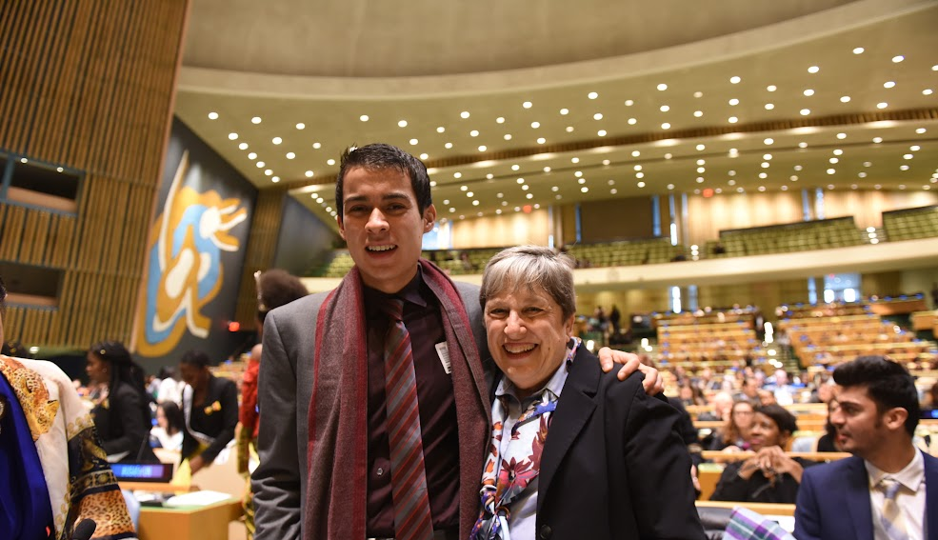

OVERVIEW
The United Nations Association of the USA (UNA-USA) is a movement of Americans dedicated to supporting the United Nations. With more than 20,000 members (60% under the age of 26) and 225 chapters across the country, UNA-USA members are united in their commitment to global engagement and their belief that each of us can play a part in advancing the UN’s mission and achieving the Sustainable Development Goals and a more equitable and sustainable future for all.

In honor of the United Nation’s 77th anniversary, UNA-USA will host its first ever Intergenerational Model UN conference (IGMUN) on Friday, October 21, 2022. The virtual conference is an opportunity for participants of all ages and walks of life to step into the shoes of UN Ambassadors and debate a range of issues on the UN agenda. This all-day program is designed as a teaching and learning opportunity and is intended for both novices and delegates with prior Model UN experience. Participants will be assigned as country delegates to work within a specific committee to debate significant and timely global issues. During the committee session, delegates will discuss and lobby fellow country representatives to collaborate and jointly write resolutions to promote their country’s agenda.
Delegates will be joined by notable local and national leaders in civic affairs, international relations, and social issues. The IGMUN experience is meant to cultivate international understanding, life skills, and the attitudes necessary for responsible and active global citizenship. Participants can also sharpen their skills in public speaking, debating, critical thinking, teamwork, diplomacy, conflict resolution, and leadership.
Most of all, IGMUN is a chance for Americans to get together to intimately understand and appreciate, through reenactment and compromise, the importance and the challenges that delegates in the United Nations face. For program details, please see Appendix A.
TARGET AUDIENCE
The event is expected to have 350 online participants: UNA-USA members, members of U.S.-based UN agencies/networks, champions for Shot@Life, Girl Up, United to Beat Malaria, and members of the public (with a U.S.-based address) interested in foreign affairs, diplomacy, and humanitarian issues including specific outreach to staffers of Congressional offices.

SIGNATURE SPONSORSHIP OPPORTUNITY ($25,000)
This event offers a unique opportunity for your businesses to elevate its commitment to advancing global engagement and to authentically connect with our shared audiences on important global issues which impact our communities.

Sponsorship Components
Pre-Event
  - Logo displayed as signature sponsor on UNA-USA event homepage
  - Listing of logo on UNA-USA Sponsorship Page
  - 5 complimentary registrations
  - Logo on registration email
  - Social media promotion/Sponsorship announcement
During Event
  - Acknowledgement by UNA-USA official of Signature sponsorship during the Opening & Closing Plenaries (on both Day 1 and Day 2)
  - Opening Plenary Remarks by Signature Sponsor (2–3-minute message)
  - Logo in the lobby and on intro and outro graphics/slides
Post-Event
- Comprehensive event data and analytics
- Event recordings and transcripts for content repurposing
  - Branding in all emails to registrants (both attendees and no-shows)

Please contact Rachel Bowen Pittman, UNA-USA Executive Director, at rpittman@unausa.org for further discussion about this opportunity. Thank you in advance!
APPENDIX A

2022 Tentative SPEAKERS, Session Topics & SPECIAL PROGRAMS

9:30 am - 10:30 am Speed Networking

10:30 am - 11:15 am Opening Ceremony
- Keynote Speaker
- UNA-USA Member Awards

11:15 am - 11:30 am Break

11:30 am - 12:30 pm Committee Trainings:
- Security Council = experienced Model UN participants only
- UN Environment Programme - oceans/climate
- UNICEF - children’s health and wellbeing
- UNHCR - refugees
- WFP - food insecurity
- WHO - malaria

12:30 pm - 1:15 pm UN Subject Matter Experts presentation within each committee

1:15 pm - 1:30 pm Break

1:30 pm - 4:00 pm Debate and Discussion

4:00 pm - 4:15 pm Wrap Up and Advocacy Ask within committee

4:15 pm - 4:30 pm Break

4:30 pm - 5:15 pm Closing Plenary
- Keynote Speaker
- Committee Debrief and Resolution Presentation
- Committee Awards

